TIM 155: Problem Set 9

Due Thursday, June 8, in class.

1. Our consulting firm is conducting a watershed assessment for the Arroyo Seco watershed (Figure 1) in southern California. The water district needs to calculate its average change in surface water storage in order to plan for future growth in the region. From the initial research, you have gathered the following estimates in the table below. The water district also informed you that the region does not export any water.

Remember the water budget equation we reviewed in class:
INFLOW = OUTFLOW +/- CHANGE IN STORAGE
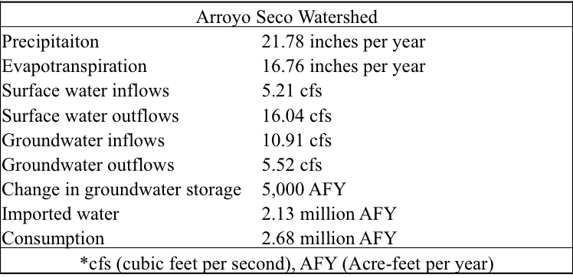

Calculate the average change in surface water for the region and report it in AFY (Acre-feet per year). Please show your work. Explain what your result indicates in terms of the sustainability of water availability in this region. (4 points)

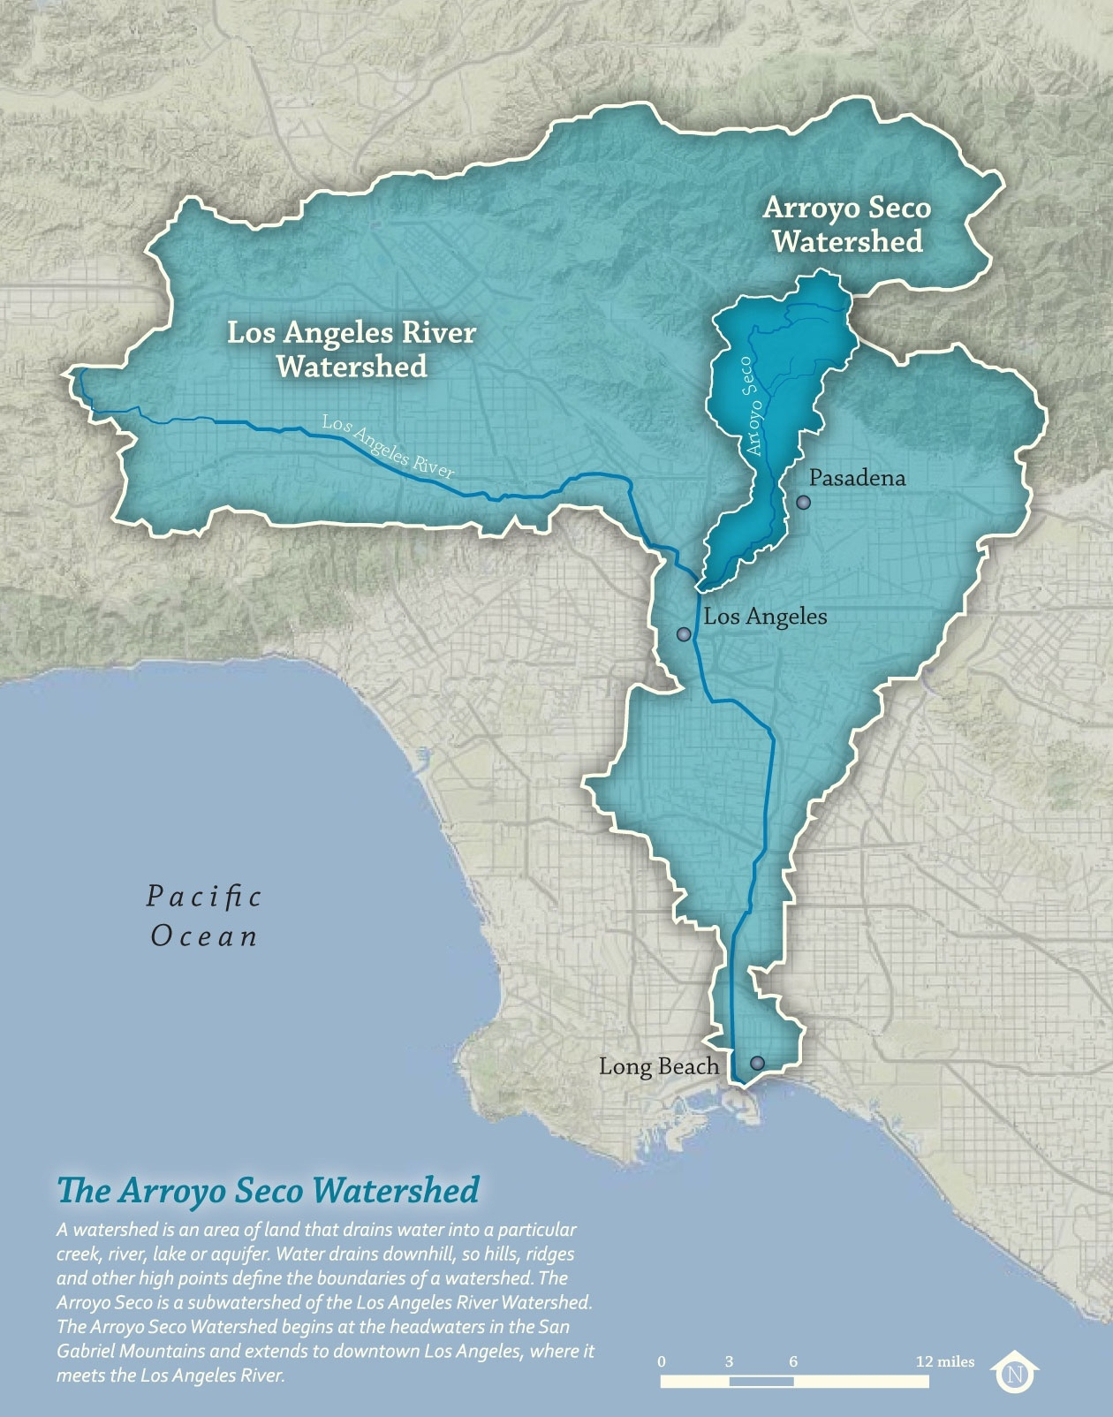
Figure 1: The Arroyo Seco Watershed in dark blue. Total area: 46.6 square miles.
Image credit: The Arroyo Seco foundation.

2. Week 9’s readings include a 2004 overview paper of urban water reuse by Levine and Asano, and a 2012 report by a committee of the National Research Council (NRC).
This question examines what happened during the 8 years between the publication of the two reports in the world of urban water reuse. Read the Levine/Asano article and take notes on what the state of water reuse was in 2004. Then read the first two chapters of the NRC report. Using the bold-faced section headings from Levine/Asano as your organizing guide (e.g., water usage patterns, reclaimed water primer), explain what is the same and what is different between the two reports. If the NRC report doesn’t address something, simply put down the section title and N/A. If it does, explain if the two writings are the same or different, and if so, different in what way. At the end of the analysis, say what you think is the most important change in water reclamation and reuse over the 8-year period. (5 points)

